**EXECUTIVE SUMMARY**

Following the 2017 Northern California fires, we analysed 3 food production sites across Sonoma County at varying distances from the urban burn areas in Santa Rosa. We tested washed and unwashed samples of kale leaves, collected by community volunteers during the fire, as well as soil samples collected by community volunteers in June of 2018.

Results confirmed our hypothesis that produce was not significantly affected by the fire. Our cumulative analysis further suggests that eating trace contaminants on produce does not provide a significant chemical exposure during an urban wildfire event, and the potential cancer risk is outweighed by the cancer risk reduction from the nutritional value of eating produce. More analysis is needed on dioxin in Santa Rosa soils. Our report provides additional information on best practices for further reducing risk and enhacing protective factors.

* Produce Summary: ***low concern***
  + Produce samples did not have any detectable Polycyclic Aromatic Hydrocarbons (PAHs), or Polychlorinated Biphenyls (PCBs).
  + Produce did not have any detectable Dioxins and Furans in 12 out of 13 samples. The sample with detectable levels was still at a concentration below California’s “No Significant Risk Level” threshold for determining chemical safety under Proposition 65.
  + Produce did not have any detectable Proposition 65-regulated heavy metals in 12 out of 13 samples. One sample contained nickel at levels that exceed the Prop 65 NSRL. No samples had detectable levels of lead, arsenic, mercury, or chromium.
* Soil Summary: ***low concern, more soil dioxin testing needed in Santa Rosa***
  + Heavy metal soil concentrations were below Sonoma County’s post-fire clean-up goals.
  + The site closest to the Santa Rosa fires had the highest levels of dioxins and furans, at levels that exceed EPA and OEHHA soil screening levels.
  + We are unable to confirm whether these contaminants were present before the fire or are a result of the fire.
  + Soil samples did not have any detectable Polychlorinated Biphenyls (PCBs).
* General Notes: ***the need for a balanced approach in assessing risk***
  + *Over long periods of time*, exposure to these chemical groups at very low levels can still contribute to health impacts, including at *levels below what our tests are able to detect*.
  + *Numerous health benefits including cancer risk reduction* have been attributed to green leafy vegetables. These benefits outweigh the risk from trace contaminants in produce.
  + *Some individuals have higher risks* and should talk with their healthcare provider to better understand if they should take extra precautions. Individuals at higher risk may also benefit greatly from the high nutrition in green leafy vegetables and fresh produce.
  + *Best practices for reducing risk* *include*: wearing a respirator mask; washing produce thoroughly in running water; peeling root vegetables, testing soil regularly; containing and amending contaminated soil through sheet mulching, raised beds, and compost.
  + *Best practices that enhance protective factors* should also be pursued, such as increasing produce consumption to promote healthy nutrition and resilience to chemical exposures.

**BACKGROUND & SAMPLING METHODS**

***Urbal Wildfire and Potential Contamination***

The fires that spread through Northern California in October 2017 burned over 160,000 acres of wildland, suburban, urban and industrial areas, creating dangerous air quality conditions for the region that lasted long beyond the fires themselves. The wildfire smoke likely included high concentrations of toxic air contaminants.[1] Following the fires, the Food and Drug Administration wrote a letter to the California Department of Food and Agriculture and the California Department of Public Health, stating that “toxic elements, firefighting chemicals, and combustion products such as polycyclic aromatic hydrocarbons (PAHs) and dioxins are of greatest concern.” There are well-known human health impacts from the *inhalation* of these contaminants[2]. Additionally, plants have the potential to absorb air pollutants directly through their leaves,[3],[4],[5],[6] but little research has been done on the risk to human health from *ingesting* contaminants from smoke and ash on produce grown near a wildfire.

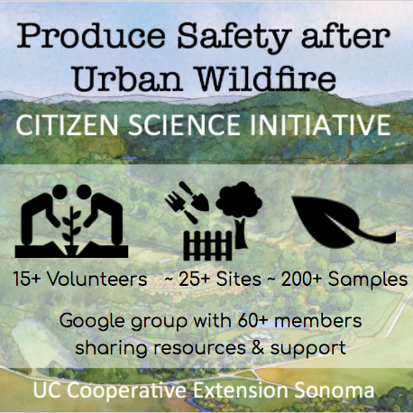***Impact on Local Farms and Gardens***

Local farms and gardens played a significant role in food relief efforts immediately following the fires, contributing produce to shelters and kitchens. Many farmers, gardeners, and community members have been concerned about how the fire-related air pollution might impact locally-grown produce. Farmers have been unsure of the potential health impacts of the fire on themselves, their workers, and their consumers. School, community, and home gardeners have been concerned about the potential health impact on children and other vulnerable groups.

***Citizen Science Initiative***

In the weeks following the Sonoma County fires, concerned community members came together to launch the Produce Safety after Urban Wildfire Citizen Science Initiative. Sonoma County residents and members of the UC Master Gardener Program of Sonoma County collaborated to take samples from over 25 sites across the region using a sampling protocol created under advisement by UC Environmental Health and Food Safety Specialists. Samples included washed and unwashed produce, each in triplicate, to determine if contaminants are present and whether contaminants can be easily washed off produce. Volunteers focused on leafy greens with large surface area directly exposed to air pollution: kale, collards, chard, and lettuce. In total, over 200 samples were taken and frozen for subsequent laboratory analysis.

In the months following the fire, soil contamination became a greater concern for the community. Community-led soil sampling was initiated in June 2018 using a protocol developed in collaboration with UC Berkeley graduate students. Three sites were analysed to test for persistent chemicals in the soil.

**POTENTIAL HAZARDS FROM SMOKE**

The short and long-term health impacts of smoke inhalation have been well documented over the past century, particularly from the study of occupational exposures in factories. In 1963, the Clean Air Act created a national mandate to monitor and control air pollution, and created a list of 6 “criteria air pollutants” for which the EPA sets national standards for enforcement: carbon monoxide, lead, ground-level ozone, nitrogen dioxide, particulate matter, and sulfur dioxide.

* WILDFIRE SMOKE
* URBAN WILDFIRE SMOKE
* INGESTION OF PERSISTANT AIR POLLUTANTS

|  |  |  |
| --- | --- | --- |
| **Polycyclic Aromatic Hydrocarbons (PAHs) [7]** are a class of very small carcinogenic chemicals that come from the combustion of organic materials. Traffic-related air pollution is a common source. They also enter the diet through grilling, drying, and smoking foods. PAHs generally have a low degree of *acute* toxicity to humans, with effects occuring only over time. Some PAHs impact brain development in fetuses and children. |  | **Heavy Metals [8]**  are persistent contaminants. They exist naturally in soil, but can be emitted in toxic levels from industrial activities. During an urban fire, they could be present in smoke from burning buildings and cars. Some are critical nutrients for life, like iron for red blood cell function. Others, like lead, arsenic, and mercury, can be carcinogenic, toxic to many organ systems, and cause developmental effects on fetuses and children. |
|  |  |  |
| **Polychlorinated Biphenyls (PCBs)** |  | **Dioxins & Furans[9]**  are persistent organic pollutants. They are created through the combustion of plastic products and can travel long distances through air pollution. They bind to fats and will accumulate up the food-chain, including breast milk. Toxic effects inclue immune toxicity, developmental, and hormonal effects. Children and breastfeeding infants are more at risk for long-term health impacts. |

**DETERMINING RISK**

***Foliar Samples: Proposition 65***

**“No Significant Risk Level” (NSRL)**

According to the OEHHA website, Proposition 65 *“defines “no significant risk” as a level of exposure that would cause no more than 1 extra case of cancer in 100,000 people over a 70-year lifetime. So a compound can be unlabeled if a person exposed to the substance at the expected level for 70 years is estimated to have a 1 in 100,000 chance or less of getting cancer due to that exposure. The law also has similar strict cutoff levels for birth defects and reproductive harm.”*

In order to determine whether levels of contaminants on produce were “safe”, we compared our laboratory results to the “No Significant Risk Level” (NSRL) established by California’s Occupational and Environmental Health Hazard Assessments (OEHHA) under Proposition 65[10].

Proposition 65 is officially known as the “Safe Drinking Water and Toxic Enforcement Act of 1986”. It was enacted as a ballot initiative to protect drinking water and inform Californians about exposures to chemicals shown to cause cancer, reproductive harm, and neurological impacts. Under the law, businesses selling products containing these chemicals at levels that pose significant risk must inform customers with a Proposition 65 warning on the package.

***Soil Samples: Soil Screening Levels***

**“Target Cancer Risk”**

Both OEHHA and the EPA calculate their soil screening levels based on a target cancer risk of 1 extra case of cacer in a million people, making it even stricter than the Proposition 65 levels. As with Prop 65, these soil standards are calculated for cancer risk over a 70-year lifetime of exposure.

We used soil screening levels from the Environmental Protection Agency (EPA) and OEHHA.

We used the EPA’s Regional Soil Screening tables, and selected the Resident Soil level with a target hazard quotient of 1[11]. We used OEHHA’s California Human Health Screening Levels (CHHSLs) table and selected the Residential Scenario values[12].

For heavy metals, we also compared our laboaratory results to the Sonoma County Complex Fire Cleanup Goals set by the Sonoma County Department of Health Services Public Health Division[13].

***Cumulative Risk Assessment***

Rather than examining only one chemical and only one route of exposure, our study uses a cumulative approach to examine the total set of exposures that could impact health, including and beyond chemical exposures. Wildfires hitting an urban area create innumerable **health hazards** for communities and the smoke from the fire can impact an even larger geographic area. When evaluating smoke on local produce, a **cumulative risk assessment** provides a more balanced evaluation of **protective factors** from local food, such as the health benefits of open green spaces and nutritious produce, and the socio-economic impacts of a strong local economy and interconnected community.

***Limitations***

There are a number of significant limitations of our method. These include: low sample number, lack of replicates in many samples, lack of an adequate control sample for comparison, and a risk assessment approach that assumes chronic exposures.

**“Acute, Chronic & Subchronic”**

*The length of the exposure can make a significant difference in whether or not an exposure has health consequences.*

***Acute*** *= exposure for under 24 hours*

***Subchronic*** *= repeated exposure for more than 30 days, up to 10% of the lifespan*

***Chronic*** *= repeated exposure for more than 10% of the life span in humans (90 days to 2 years is typically used in lab animal studies)*

The risk assessment methods that we have been using in this preliminary report **assumes a 70-year lifetime of exposure at the daily intake rate.** Consuming local produce following an urban wildfire likely results in an acute or sub-chronic exposure due to the wildfire incident[14]. The increasing frequency of wildfires means that a person may experience recurring acute or subacute exposures over their lifetime. However, exposure due to local produce is not likely to have a daily lifetime intake rates.

**Due to this significant method limitation, we suggest that all results be interpreted as conservative overestimates of risk.**

***These methods provide an overestimate of risk.***

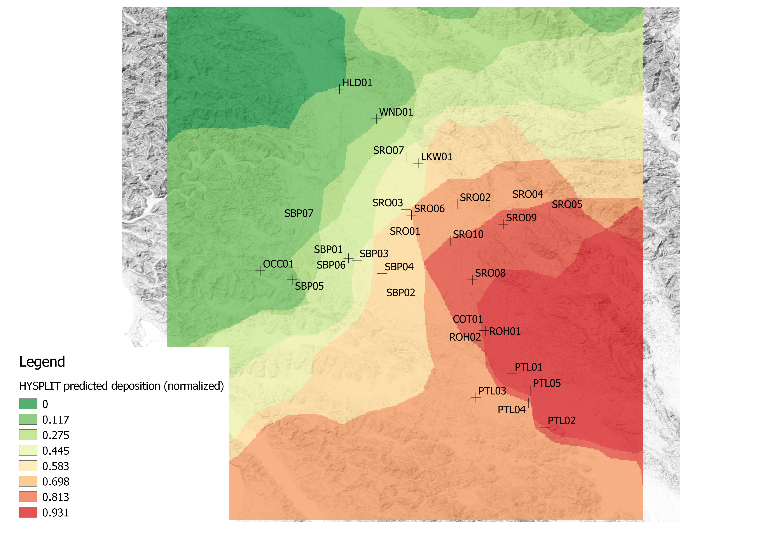**PRELIMINARY ANALYSIS & STUDY HYPOTHESIS**

***Site Selection***

Our preliminary analysis tested samples from two high-priority sites that were most likely to have received deposits of toxic air contaminants from the urban burn. We created a meteorological model of particulate matter deposition (NOAA HYSPLIT) from the urban burn area in Santa Rosa, and used this model to choose sites that were most likely to have chemicals from the smoke settle on their crops.

***Samples, Tests, and Labs***

We provided two varieties of leafy greens (kale, lettuce) from the two sites to TestAmerica in Sacramento for analysis for PAHs, CAM17 metals, and dioxins and furans. We then sent another set of samples from the same two high priority sites to Enthalpy Analytics in Berkeley to help validate our first results. With this second lab, we tested for PAHs in chard samples from both sites, and we tested for dioxins using collards from one site

Results from the HYSPLIT meteorological model, predicting deposition of particles (rescaled as a proportion of maximum deposition)

**Based on these preliminary findings, we hypothesized that produce safety was not significantly affected by the fires and that heavy metal deposits may be mitigated by washing produce.**

Preliminary did not indicate a high degree of contamination:

* **Polycyclic Aromatic Hydrocarbons *= inconclusive;*** Due to high method reporting limits from our laboratories
* **Heavy metals =** ***low concern, except for Nickel***; No detection of lead, arsenic, or mercury. Nickel was found in 2 of 8 samples at levels exceeding Prop 65’s No Significant Risk Level (NSRL). Nickel contamination appears to be mitigated by washing produce.
* **Dioxins = *some concern*;** Concentrations found above the background levels from FDA’s Dioxin Monitoring Program, but at levels below NSRL.

Results from model based on CARB air quality sensor data. White dots are sampling sites for this study. Red dots are air quality sampling stations included in the model. Colors indicate the cumulative air pollution exposure (rescaled as a proportion of maximum exposure). Highest air quality pollution values were from the Napa and Sonomal sensor locations, east of the map extent.

**HYPOTHESIS TESTING**

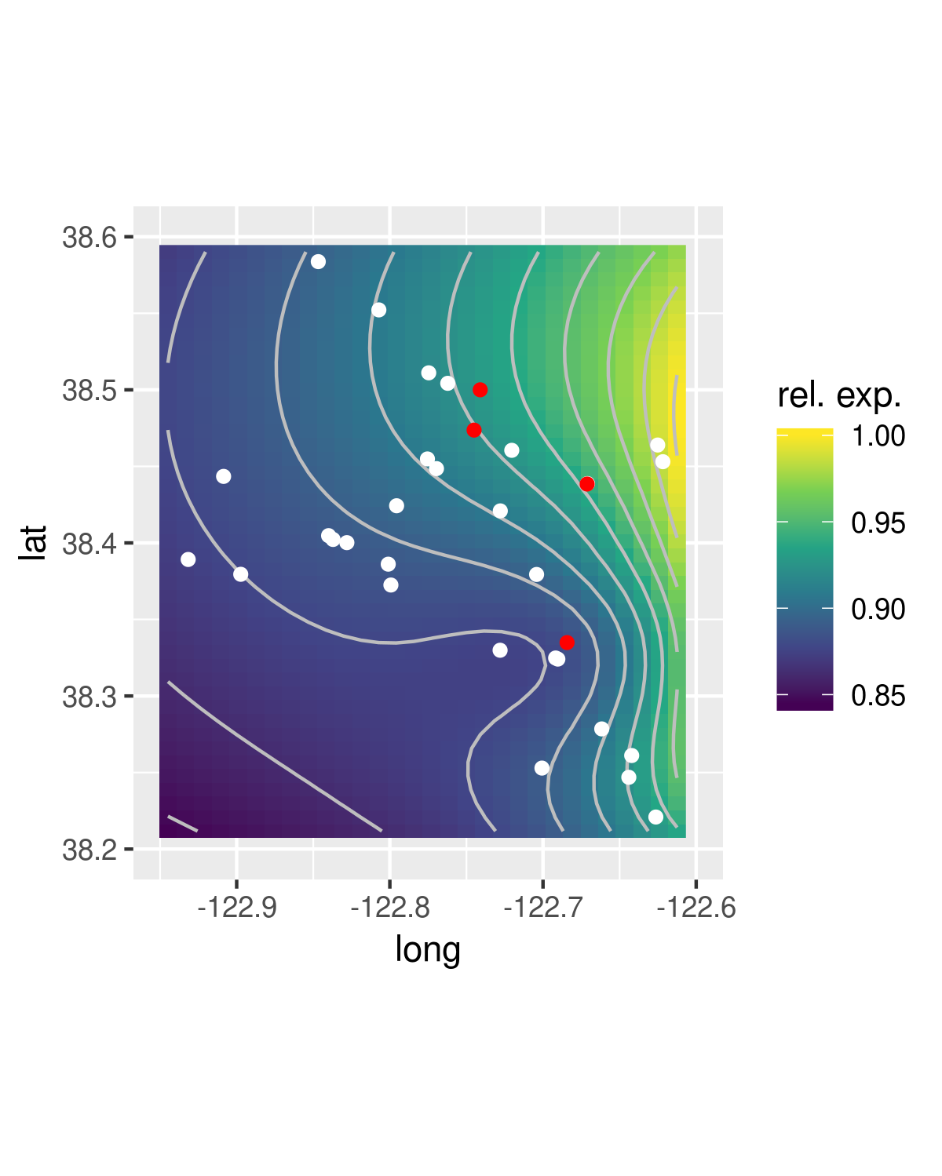

***Site Selection***

We selected three sites for additional testing based on three variables: distance from urban burn area, ranking on meteorological deposition model used in preliminary analysis, and ranking on particulate matter levels during fire. For this third variable, we analyzed Sonoma County air quality sensor data collected during October 2017, provided by California Air Resource Board (CARB). Initially, sites’ exposure according to air-quality models were independent to the exposure predicted by the deposition model, causing concern about model accuracy. Analyses conducted after the fact found that some air quality sensors had anomalously low values. Excluding these sensors led to results (pictured here) more correlated to those of the deposition model.

***Samples, Tests, and Labs***

For these three sites, we sent kale samples to Enthalpy Analytical for testing in Polycyclic Aromatic Hydrocarbons, Polychlorinated Biphenyls, Dioxins and Furans, and Heavy Metals.

We selected an additional, fourth, site in order to follow-up testing for PAHs. This site was selected as a high ranking site for multiple of the above site selection variables. We also selected it due to the larger sample mass available, as this was intended to increase the chances of a lower detection level (higher resolution of analysis).

|  |  |  |  |
| --- | --- | --- | --- |
| **Santa Rosa Site** | **Santa Rosa Site** | **Rohnert Park Site** | **Petaluma Site** |
| PAHs | PAHs  PCBs  Dioxins & Furans  Heavy Metals | PAHs  PCBs  Dioxins & Furans  Heavy Metals | PAHs  PCBs  Dioxins & Furans  Heavy Metals |

|  |  |  |  |  |  |  |  |  |  |  |  |  |  |  |  |  |  |  |  |  |  |
| --- | --- | --- | --- | --- | --- | --- | --- | --- | --- | --- | --- | --- | --- | --- | --- | --- | --- | --- | --- | --- | --- |
| **RESULTS: PLANT TISSUE**  **Polychlorinated Biphenyls (PCBs) Summary – Plant Tissue**  Interpretation: There were no PCBs detected in the plant samples from any site. However, due to the high reporting limit from standard laboratory methods, we are not able to confirm whether or not your site has PCBs at levels below our reporting limit that still exceed the Proposition 65 NSRL.  Table 1 shows how Proposition 65’s “No Significant Risk Level” (NSRL) compares to the “reporting limit” (RL) from our lab, which is the lowest level that our tests are able to detect. E.g. Concentrations above 0.09 ug/day but below 0.11 ug/day would exceed Prop 65 NSRL levels, but would not be detected by our test.  **“Reporting Limit”**  *A method reporting limit (MRL) is the lowest concentration of a chemical that a lab test would be able to detect in a sample. This is also sometimes refered to as the Detection Limit (DL), Limit of Detection (LOD), or Estimated Detection Limit (EDL) depending on the test.*  A value is given for the lowest PCB reporting limit (min RL) and for the highest PCB reporting limit (max RL).  Key: ND= “Non-Detect”; RL= “Reporting Limit”   |  |  |  |  |  | | --- | --- | --- | --- | --- | | **Table 1: Proposition 65 Comparisons for PCBs (ug/day)** | | | | | |  | NSRL | Daily Intake from Levels Found at Sites  ND=0 | Daily Intake at Reporting Limit ND=5.6 **(min RL)** | Daily Intake at Reporting Limit ND=82 **(max RL)** | | PCB Intake Rate (ug/day) | 0.09 | 0 | 0.1176 | 1.722 | | |  | | --- | |  | |  |  |  |  |

|  |  |  |  |  |  |  |  |  |  |  |  |  |  |  |
| --- | --- | --- | --- | --- | --- | --- | --- | --- | --- | --- | --- | --- | --- | --- |
| **Polycyclic Aromatic Hydrocarbons (PAHs) Summary – Plant Tissue**  Interpretation: There were no PAHs detected in the plant samples from your site. However, due to the high reporting limit from standard laboratory methods, we are not able to confirm whether or not your site has PAHs at levels below our reporting limit that still exceed the Proposition 65 NSRL.  Table 2 shows how Proposition 65’s “No Significant Risk Level” (NSRL) for several different PAHs compares to the “method reporting limit” (MRL) from our lab, which is the lowest level that our tests are able to detect. The MRL listed in table 2 is an average across all samples of washed and unwashed produce taken from all sites.  **Table 2: Proposition 65 comparisons for PAHs (ug/day)**   |  |  |  |  | | --- | --- | --- | --- | |  | NSRL for Benzo(a) pyrene | Daily Intake from Levels Found at Sites  ND=0 | Daily Intake at  Reporting Limit  ND=178.33  **(average RL)** | | PAH Intake Rate (ug/day) | 0.06 | 0 | 0.7489 | | |  | | --- | |  | |  |  |  |  |

For Example: Daily Intake of benzo(a)pyrene above 0.06 ug/day but below 7.489 ug/day would exceed Prop 65 NSRL levels, but would not be detected by our test.

**Dioxins & Furans Summary – Plant Tissue**

Interpretation: Some dioxins or furans were detected in 4 out of 7 samples from your site, but no samples had detectable levels of the higher-toxicity dioxins that are of greatest concern for public health. However, we cannot completely confirm that your site does not have dioxins & furans above the Proposition 65 NSRL due to the high detection limit from standard laboratory methods.

Table 3 and graph A shows how Proposition 65’s “No Significant Risk Level” (NSRL) compares to the “detection limit” (DL) from our lab, which is the lowest level that our tests are able to detect. It is a common convention in scientific studies to use half of the detection limit rather than “0” for non-detect results (ND=DL/2). Your ND=DL/2 results are equivalent to the Prop 65 NSRL. Key: ND= “Non-Detect”; DL= “Detection Limit”

|  |  |  |  |  |
| --- | --- | --- | --- | --- |
| **Table 3: Proposition 65 Comparisons for Dioxins and Furans** | | | | |
|  | NSRL | Background* | Daily Intake from Levels Found at Sites ND=0 | Daily Intake at Half of Reporting Limit ND=RL/2 |
| Dioxins & Furans Intake Rate  WHO-2005 TEQs (ug/day) | 5 x 10-6 | 2.23 x 10-7 | 0 | 5.07 x 10-6 |

* FDA National Dioxin Survey, average results from spinach, collards, lettuce, cabbage, 2000-2004

**Graph A: Proposition 65 Comparisons for Dioxins and Furans**

**Heavy Metals Summary – Plant Tissue**

Interpretation: Some heavy metals were detected. There were no detections of the heavy metals of greatest concern to public health, including Lead, Arsenic, Mercury, and Chromium. Nickel was detected on one sample out of eighteen tested, and only on an unwashed sample. Consuming this concentration of Nickel daily would lead to consumption rates above Proposition 65’s “No Significant Risk Level”.

Recommendations: Wash produce in running water.

Table 4 summarizes the laboratory results of plant tissue sampled from your site.

|  |  |  |  |  |  |  |  |  |  |  |  |  |  |  |  |  |  |  |  |  |  |  |  |  |  |  |  |  |  |  |  |  |  |  |  |  |  |  |  |  |  |  |  |  |  |  |  |  |  |  |  |  |  |  |  |  |  |  |  |  |  |  |  |
| --- | --- | --- | --- | --- | --- | --- | --- | --- | --- | --- | --- | --- | --- | --- | --- | --- | --- | --- | --- | --- | --- | --- | --- | --- | --- | --- | --- | --- | --- | --- | --- | --- | --- | --- | --- | --- | --- | --- | --- | --- | --- | --- | --- | --- | --- | --- | --- | --- | --- | --- | --- | --- | --- | --- | --- | --- | --- | --- | --- | --- | --- | --- | --- |
| **Table 4: Heavy Metals Concentrations ND=0 (mg/kg)**   |  |  |  |  |  |  |  | | --- | --- | --- | --- | --- | --- | --- | | Site | SRO02 | | ROH2 | | PLT04 | | | Wash Condition | Washed | Unwashed | Washed | Unwashed | Washed | Unwashed | | Replicate* | AVG | AVG | AVG | AVG | AVG | AVG | | Barium | 7.333 | 6.733 | 2.7 | 2.566 | 3.925 | 6.8 | | Copper | 0.4467 | 0.81 | 0.7567 | 0.87 | 0.71 | 0.55 | | Molybdenum | 0.6567 | 0.7467 | 0.49 | 0.4767 | 0.6975 | 0.6567 | | Nickel | 0 | 0.4433 | 0 | 0 | 0 | 0 | | Thallium | 0 | 0 | 0.8167 | 1.09 | 0 | 0 | | Zinc | 6.5 | 11.1 | 5 | 5.567 | 8.55 | 12.367 |   *This table shows averages of the triplicate samples taken for each site and wash condition |

**Heavy Metals Summary – Plant Tissue (Page 2 of 2)**

Table 5 calculates an average nickel concentration for the one site where nickel was detected. Instead of using 0 for non-detections, the table shows estimated concentrations in grey. These were created by halving the detection limit for each sample (ND=DL/2).

**Table 5: Heavy Metals Concentrations ND=DL/2 (mg/kg)**

|  |  |  |  |  |  |  |  |  |  |
| --- | --- | --- | --- | --- | --- | --- | --- | --- | --- |
| Site | **SRO02** | | | | | |  | | |
| Wash Condition | **Washed** | | | **Unwashed** | | | |  | |
| Replicate | **1** | **2** | **3** | **1** | **2** | **3** | | | AVG |
| Nickel | 0.16* | 0.2 | 0.195 | **0.41\*\*** | 0.215 | 0.245 | | | 0.2375 |

*Numbers in grey represent DL/2 **Lab measurements

Table 6 compares the Proposition 65 “No Significant Risk Level” to the total daily Nickel intake that would occur if a person were to eat 21 grams of green leafy vegetables per day, with all produce containing **0.2375 mg/kg** of Nickel.

|  |  |  |  |
| --- | --- | --- | --- |
| **Table 6: Proposition 65 Comparison for Nickel** | |  | |
|  | Nickel | | |
|  | NSRL | | Daily Intake |
| Total Daily Nickel Intake ND=DL/2 (ug/day) | 0.8 | | 4.9875 |

**RESULTS: SOIL**

**Polychlorinated Biphenyls (PCBs) Summary – Soil**

Interpretation: There were no PCBs detected in the soil sample. The reporting limit from our laboratory methods are far below the EPA’s PCB soil screening levels, so we can confidently conclude that no PCBs are present at hazardous levels in soil.

Table 7 shows a comparison of the reporting limits from our laboratory methods with the EPA’s screening levels for PCBs in soil.

**Table 7: Comparison of Reporting Limit to Screening Level (ug/Kg)**

|  |  |  |  |  |
| --- | --- | --- | --- | --- |
| Site | **EPA Screening Level** | **SRO02**  **Reporting Limit** | **ROH02**  **Reporting Limit** | **PTL04**  **Reporting Limit** |
| Aroclor-1016 | 411 | 13 | 12 | 12 |
| Aroclor-1221 | 2000 | 26 | 24 | 24 |
| Aroclor-1232 | 1720 | 13 | 12 | 12 |
| Aroclor-1242 | 2300 | 13 | 12 | 12 |
| Aroclor-1248 | 2310 | 13 | 12 | 12 |
| Aroclor-1254 | 176 | 13 | 12 | 12 |
| Aroclor-1260 | 2400 | 13 | 12 | 12 |

**Dioxins & Furans Summary – Soil (Page 1 of 2)**

Interpretation: Several dioxins and furans were detected in soil from your site at cumulative concentrations that exceed the EPA and OEHHA’s Screening Levels.

Recommendations: The main concern with soil dioxin contamination is from direct inhalation and ingestion of soil. Children are more likely to ingest soil. *Short-term*: Reduce direct contact with soil. Wash hands after working with soil. Wash produce thoroughly, and peel root vegetables. *Long-term*: Heavily amend soil with compost and mulch to dilute dioxins and build up. Use drip irrigation to reduce the up-splash of soil and dust. Re-test soil.

|  |  |  |  |  |  |  |  |  |
| --- | --- | --- | --- | --- | --- | --- | --- | --- |
| Table 8 shows a ***cumulative dioxin concentration*** for the tested sites. These values are created by scaling the concentrations of each dioxin and furan detected (Table 5) by the relative toxicity of each dioxin or furan. This is known as the “Toxic Equivalency Factor” (TEQ). We used the TEQs proposed by the World Health Organization (WHO) in 2005. We compared this cumulative dioxin concentration to the soil dioxin screening level proposed by the EPA.  Key: ND= “Non-detect”, DL= “Detection Limit”, SL= “Screening Level”  **Table 8: Cumulative Dioxin Concentration WHO 2005 TEQ ND=DL/2 (pg/g)** | | | | | | | |  |
|  | Site | **SRO02** | **ROH02** | **PLT04** | EPA SL | OEHHA SL |  | |
|  | Replicate | Average | Average | Average |  |  |  | |
|  | Soil Dioxin Concentration | 13.2 | 2.2133 | 2.3867 | 4.77 | 4.6 |  | |

**Graph B: Cumulative Dioxin Concentration WHO 2005 TEQ ND=DL/2 (pg/g)**

**Heavy Metals Summary – Soil**

Interpretation: Some heavy metals were found in soil from your site. All levels were below Sonoma County Clean-Up Goals, and all metals except for arsenic were detected at levels below the EPA’s Screening Levels. Arsenic was detected above EPA’s Screening Level, but this is likely due to high background levels in the region.

Table 9 compares the average heavy metals concentration from your site to regional background levels, federal (USA EPA) and state (CalEPA) soil screening levels, and to the Clean-Up Goals set by the Sonoma County Department of Health Services.

**Table 9: Heavy Metals comparison to standards and clean up goals ND=0 (mg/kg)**

|  |  |  |  |  |  |  |  |
| --- | --- | --- | --- | --- | --- | --- | --- |
|  | SRO02 | ROH02 | PTL04 | Sonoma County Complex Fire clean-up goals. | | | |
|  | AVG | AVG | AVG | Background | USA EPA RSL | CAlEPA CHHSL | Clean-Up Goal |
| Arsenic | 4.567 | 2.833 | 2.7 | 6.18 | 0.7 | 0.1 | 6.2 |
| Barium | 183.33 | 120 | 140 | 263.2 | 15000 | 5200 | 5200 |
| Beryllium | 0.49 | 0.5767 | 0.303 | 2079 | 160 | 16 | 15 |
| Cadmium | 0.5233 | 0.26 | 0.43 | 0.184 | 71 | 1.7 | 1.7 |
| Chromium | 51.667 | 34 | 25 | 110 | 120000 | 100000 | 36000 |
| Cobalt | 10.667 | 12.67 | 8.5 | 29.2 | 23 | 660 | 29.2 |
| Copper | 40.667 | 26 | 18 | 40.35 | 3100 | 3000 | 3000 |
| Lead | 27.333 | 7.667 | 55.67 | 39.76 | 400 | 80 | 80 |
| Mercury | 0.17 | 0.0883 | 0.062 | 3.19 | 5.1 | 18 | 5.1 |
| Molybdenum | 0.42 | 0.5967 | 0.4567 | 0.759 | 390 | 380 | 380 |
| Nickel | 67.333 | 47 | 16.33 | 102.7 | 1500 | 1600 | 490 |
| Vanadium | 35.333 | 41.667 | 22.667 | 120 | 390 | 530 | 390 |
| Zinc | 180 | 109.67 | 116.67 | 74.5 | 23000 | 23000 | 23000 |

**CUMULATIVE RISK ASSESSMENT**

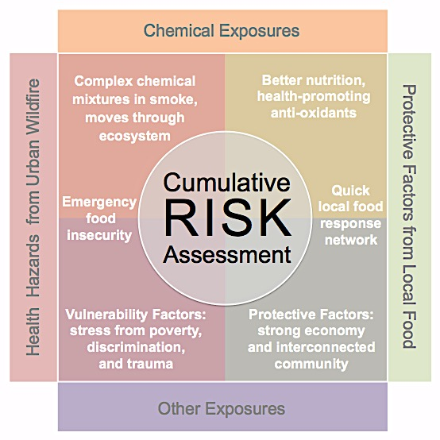

Our cumulative assessment is broken down into the following subsections:

1. Evaluation of chemical mixtures from multiple media  
   1. Ingestion of produce
   2. Ingestion and dermal absorption of soil
2. Risk-benefit analysis of chemical exposures in local produce   
   1. Risk of other chemical exposures in food system
   2. Benefit of nutrition from eating produce
3. Other health-impacting exposures associated with urban wildfire and local produce   
   1. Smoke inhalation
   2. Social and economic stressors of wildfire, including emergency food insecurity
   3. Social and economic benefits associated with local produce and implications for community resilience to future disaster
4. Social determinants of health   
   1. Evaluating the complex mixture of chemical and non-chemical exposures
   2. Evaluating vulnerability of certain populations, such as children, food insecure communities, and communities experiencing a higher level of both chemical and non-chemical exposures.[15]

**1. Evaluation of chemical mixtures from multiple media**

This study examined multiple chemical groups that were likely to be present in smoke, and so an evaluation of the risk from mixtures is warranted. In 1996, the Safe Drinking Water Act required the EPA to create methods for the evaluation of mixtures of chemicals that are likely to co-occur in specific media, and since then multiple frameworks have been tested. [16], [17]

To establish cumulative risk values, we used OEHHA’s Air Toxics Hotspots Exposure Assessment guidance documents.[18] As with the chemical-specific risks, this cumulative method assumes a 70-year life-time of exposure. It differs from our Proposition 65 analyses in that it calculates different risks for particular age groups, and then sums them across the 70-year life-time, which is particularly useful for behaviors such as soil ingestion, which is most likely to occur in children between 0-2 years of age.

**a. Ingestion of contamination on plant tissue**

We used the calculations described in the Air Toxics Hotspots Exposure Assessment Chapter 7: “Home Produced Food Exposure Assessment”.

We created three scenarios in our calculations: “Maximum Possible Risk,” which uses all reporting limit values for non-detected chemicals (ND=DL), “Maximum Probable Risk,” which uses half the detection limit (ND=DL/2), and “Risk from Detected Levels,” which examines only the risk from detected chemicals and counts all non-detects as zero (ND=0).

**Risk from ingestion of produce exposed to wildfire smoke**

|  |  |  |  |
| --- | --- | --- | --- |
|  | MAXIMUM POSSIBLE RISK ND=DL | MAXIMUM PROBABLE RISK ND=DL/2 | RISK FROM DETECTED LEVELS ND=0 |
| Lifetime Cancer Risk | 0.00568 | 0.00288 | 1.28167E-09 |
| Cancer Cases per year attributable to local food contamination* | 41 | 21 | 0 |

*Lifetime Cancer Risk multiplied by Sonoma County population of 500,000, divided by 70 to convert lifetime risk into a annual figure[19]

**How to interpret the “Maximum Possible Risk”:**

If the entire population of Sonoma County ate only local produce every day for the rest of their lives, and that produce were contaminated at levels just below our ability to detect (ND=RL), it would lead to a life-time cancer risk of 0.00568, contributing an additional 41 cancer cases per year in Sonoma County’s 500,000 person population.

***This method provides an extremely high overestimate of risk.***

*It’s utility is in understanding the worst-possible risk scenario given the high rate of   
non-detections in our analysis and the high detection limits for our PAH and PCB tests.*

**b. Ingestion of contamination in soil**

Soil ingestion is the most common pathway of exposure to chemicals in soil. Skin absorption and inhalation of dust are secondary pathways that were not considered in this analysis. To create a risk of exposure through this media, we used the calculations described in the Air Toxics Hotspots Exposure Assessment Chapter 4: “Soil Ingestion”.

We used the same three risk categories as we did for ingestion of plant tissue. There were fewer non-detects in our soil samples, reducing the variation in risk between categories.

**Risk from ingestion of produce exposed to wildfire smoke**

|  |  |  |  |
| --- | --- | --- | --- |
|  | MAXIMUM POSSIBLE ND=DL | MAXIMUM PROBABLE ND=DL/2 | RISK FROM DETECTED LEVELS ND=0 |
| Lifetime Cancer Risk | 0.000467 | 0.000467 | 0.000466 |
| Cancer Cases per year attributable to local food contamination* | 3 | 3 | 3 |

*Lifetime Cancer Risk multiplied by Sonoma County population of 500,000, divided by 70 to convert lifetime risk into a annual figure[20]

**How to interpret the “Maximum Possible Risk”:**

If the entire population of Sonoma County were exposed to contaminated soil every day of their life, and that soil were contaminated at levels just below our ability to detect (ND=RL), it would lead to a life-time cancer risk of 0.000467, contributing an additional 3 cancer cases per year in Sonoma County’s 500,000 person population.

**Lifetime cancer risk by age of exposure**

Over two-thirds of this total lifetime cancer risk is attributable to exposures during 0-2 years of age

**2. Risk-Benefit Analysis**

The choice of whether or not to consume local produce following a wildfire event requires that consumers make other choices about what to eat instead. Risk-Benefit Analyses are useful tools to weigh these various choices.

**a. Risk of other chemical exposures in food system**

Of the chemicals that we evaluated in this study, produce is not typically the primary route of exposure within the food system. Therefore, consumers reducing their consumption of local produce and increasing their consumption of eggs, dairy, meat, or processed foods may increase their overall chemical exposure from food.

For instance:

* Dioxins and other fat-soluble chemicals are more likely to accumulate in meat and dairy products. The FDA dioxin monitoring project showed that, compared to fruits and vegetables, dairy products likely contribute three times more dioxins to the American diet, and meats contribute nine times more.[21]
* Polycyclic Aromatic Hydrocarbons are most commonly found in food that has been processed (especially smoking or drying) and foods that are cooked at high temperatures. PAH levels in smoked meat and fish can be as high as 200 ug/kg.[22]
* FDA’s Total Diet Study tracks heavy metals throughout the food system. Meat and processed foods are typically the highest contributors to heavy metal exposure:
  + the highest dietary sources of arsenic are in fish and seafood (.99mg/kg in canned tuna, 0.5 mg/kg in frozen fish sticks, 0.424 mg/g fish sandwich, .315 mg/kg in shrimp, and .293 in salmon steaks);
  + the highest dietary sources of lead are in processed deserts (0.01mg/kg in canned fruit cocktail, 0.011mg/kg in milk chocolate candy bar, 0.016 mg/g in chocolate syrup, 0.01 mg/kg in brownies, 0.012mg/kg in canned sweet potatoes.
  + The highest dietary sources of nickel are in processed foods (2.1mg/kg in “Oat Ring Cereal”, 0.947 in milk chocolate candy bar, 0.927 in chocolate syrup, 0.6mg/kg in chocolate chip cookies) though it is also important to note that higher levels of nickel are also found in sunflower seeds (3.2mg/kg) and legumes (0.6mg/kg dried pinto beans, 0.577 in frozen lima beans, .489mg/kg in dry roasted peanuts)

Produce that is purchased from non-local sources are also at risk of contamination.

**b. Benefit of nutrition from eating produce**

When considering the potential for contamination in local produce, some consumers may reduce their overall produce consumption. This is particularly true of communities receiving food from local food security projects. Knowing that green leafy vegetables are also some of the most nutritiously dense foods, we conducted a quantitative risk-benefit analysis for lifetime cancer risk, using the methods outlined in Reiss et al. (2012) “Estimation of cancer risks and benefits associated with a potential increased consumption of fruits and vegetables.”

* Describe his methods
* Similar calculations to 1.a. – but instead, we assumes half of the population increased produce consumption by 80g a day
* Describe his cancer cases avoided method

**3. Other health-impacting exposures associated with urban wildfire and local produce**

* 1. Inhalation of smoke
  2. Social and economic stressors of wildfire, including emergency food insecurity
  3. Social and economic benefits associated with local produce and implications for community resilience to future disaster

<https://ehjournal.biomedcentral.com/articles/10.1186/1476-069X-11-71?TB_iframe=true&width=921.6&height=921.6>

SES & health impact of smoke inhalation

* + 1. Peri-urban ag land slowed the rate of the fire to the urban area
    2. Open space, environmental education,
    3. Resources: book Last Kid in the Woods, Restorative Commons, AHTA <https://www.ahta.org/research-info>;
    4. social benefits of community garden
    5. local economy benefits

**4. Social determinants of health**

* 1. Evaluating the complex mixture of chemical and non-chemical exposures
  2. Evaluating vulnerability of certain populations, such as children, food insecure communities, and communities experiencing a higher level of both chemical and non-chemical exposures.[23]

<http://www.publish.csiro.au/WF/WF15034>

wildfire smoke and public health risk

**CONCLUSIONS &**

**SUGGESTED BEST PRACTICES FOR REDUCING RISK**

Results confirmed our hypothesis that produce was not significantly affected by the fire. Our cumulative analysis further suggests that eating trace contaminants on produce does not provide a significant chemical exposure during an urban wildfire event, and the potential cancer risk is outweighed by the cancer risk reduction from the nutritional value of eating produce. More analysis is needed on dioxin in Santa Rosa soils.

* + *Best practices for reducing risk* *include*: wearing a respirator mask; washing produce thoroughly in running water; peeling root vegetables, testing soil regularly; containing and amending contaminated soil through sheet mulching, raised beds, and compost.
  + *Best practices that enhance protective factors* should also be pursued, such as increasing produce consumption to promote healthy nutrition and resilience to chemical exposures.

REFERENCES

1. Lemieux, Paul M. "Emissions of Organic Air Toxics from Open Burning." *Washington, DC, United States Environmental Protection Agency* 62 (2002).
2. US Environmental Protection Agency, “How Smoke From Fires can Affect Your Health”. EPA (2017). Accessed June 6, 2018. <https://airnow.gov/index.cfm?action=smoke.index>
3. Uzu, Gaëlle, et al. "Foliar lead uptake by lettuce exposed to atmospheric fallouts." *Environmental Science & Technology*44.3 (2010): 1036-1042.
4. Kipopoulou, A. M., E. Manoli, and C. Samara. "Bioconcentration of polycyclic aromatic hydrocarbons in vegetables grown in an industrial area." *Environmental pollution* 106.3 (1999): 369-380.
5. Schreck, Eva, et al. "Metal and metalloid foliar uptake by various plant species exposed to atmospheric industrial fallout: mechanisms involved for lead." *Science of the Total Environment* 427 (2012): 253-262.
6. Wennrich L, Popp P, Zeibig M. Polycyclic Aromatic Hydrocarbon Burden in Fruit and Vegetable Species Cultivated in Allotments in an Industrial Area. Int J Environ Anal Chem . (2002);82(10):667-690. doi:10.1080/0306731021000075401.
7. US Environmental Protection Agency, “Toxicological Review of Benzo[a]pyrene: Executive Summary”. EPA (2017). Accessed June 6, 2018. <https://cfpub.epa.gov/ncea/iris/iris_documents/documents/subst/0136_summary.pdf>
8. World Health Organization. "Health risks of heavy metals from long-range transboundary air pollution." *Geneve: WHO* (2007). Accessed June 6, 2018.   
   <http://apps.who.int/iris/bitstream/handle/10665/107872/E91044.pdf;jsessionid=8E1662CB3C38663A71E5A22DF47D5418?sequence=1>
9. World Health Organization. "Exposure to dioxins and dioxin-like substances: a major public health concern." *Geneve: WHO* (2010). Accessed June 6, 2018. <http://www.who.int/ipcs/features/dioxins.pdf>
10. “Current Proposition 65 No Significant Risk Levels (NSRLs) Maximum Allowable Dose Levels (MADLs).” Office of Environmental Health and Hazard Assessment. Accessed May 2018. <<https://oehha.ca.gov/proposition-65/general-info/current-proposition-65-no-significant-risk-levels-nsrls-maximum> >
11. “Regional Screening Levels (RSLs) – Generic Tables; Updated November 2018.” Environmetnal Protection Agency. Accessed December 2018. <<https://www.epa.gov/risk/regional-screening-levels-rsls-generic-tables>>
12. “California Human Health Screening Levels (CHHSLs).” Office of Environmental Health and Hazard Assessment. Accessed December 2019. <<https://oehha.ca.gov/risk-assessment/california-human-health-screening-levels-chhsls>>
13. Robinson, Barbie, and Ellen Bauer. “Sonoma County Complex Fires Health Screening Level Guidance, Cleanup Goals and Background Data Sets.” Sonoma County Department of Health Services, Public Health Division. February 28, 2018.
14. US Environmental Protection Agency, “Integrated Risk Information System Glossary.” EPA (2011). Accesed June 6, 2018 <https://iaspub.epa.gov/sor_internet/registry/termreg/searchandretrieve/  
    glossariesandkeywordlists/search.do?details=&vocabName=IRIS%20Glossary>
15. Clougherty JE, Kubzansky LD. A framework for examining social stress and susceptibility to air pollution in respiratory health. Ciênc Saúde Coletiva . 2010;15(4):2059-2074. doi:10.1590/S1413-81232010000400020.
16. Sexton K. Cumulative Risk Assessment: An Overview of Methodological Approaches for Evaluating Combined Health Effects from Exposure to Multiple Environmental Stressors. *Int J Environ Res Public Health*. 2012;9(2):370-390. doi:10.3390/ijerph9020370.
17. Pressman JG, Richardson SD, Speth TF, et al. Concentration, Chlorination, and Chemical Analysis of Drinking Water for Disinfection Byproduct Mixtures Health Effects Research: U.S. EPA’s Four Lab Study. *Environ Sci Technol*. 2010;44(19):7184-7192. doi:10.1021/es9039314.
18. “Notice of adoption of technical support document for exposure assessment and stochastic analysis Aug 2012.” Office of Enironmetnal health and Hazard Assessment. Accessed December 2018. <https://oehha.ca.gov/air/crnr/notice-adoption-technical-support-document-exposure-assessment-and-stochastic-analysis-aug>
19. Reiss et al
20. Reiss et al
21. “[2001-2004 PCDD/PCDF Exposure Estimates](https://wayback.archive-it.org/7993/20170406021806/https://www.fda.gov/Food/FoodborneIllnessContaminants/ChemicalContaminants/ucm077498.htm); Based on PCDD/PCDF Concentrations assuming ND=0”. Food and Drug Administration. Acccessed January 2019 < https://wayback.archive-it.org/7993/20170406021806/https://www.fda.gov/Food/FoodborneIllnessContaminants/ChemicalContaminants/ucm077498.htm>
22. https://ec.europa.eu/food/sites/food/files/safety/docs/sci-com_scf_out154_en.pdf
23. Clougherty JE, Kubzansky LD. A framework for examining social stress and susceptibility to air pollution in respiratory health. Ciênc Saúde Coletiva . 2010;15(4):2059-2074. doi:10.1590/S1413-81232010000400020.